**Assignment 1**

1. What is JDK? JRE? JVM?

JVM: Loads,verifies, executes code, and provides the run time. JRE: is the JVM + libraries and other files needed at run time. JDK : contains the JRE as well as development tools like the interpreter, compiler, archaiver (jar), as well as javadoc.

1. What is java compiler?

The java compiler turns user code into byte code.

1. Why is java platform independent?

The java compiles into java byte code which is independent and the JVM converts it to machine specific code. So if you compile your java code from one machine and run it at another. The JVM will interpret the byte code according to the machine specifications. In that way java is platform independent.

1. What is IDE? Why is it important for developers?

IDE’s are important because they provide rich features that aid in software development. Spellchecking, resource finding, project management, version control all in a convenient location.

1. Is java case sensitive?

Yes java is case sensitive.

1. What do the following key words do?  
   static, final, public, private, void, null, package, Class, new

Static: one copy per class, final immutable value, public: scope can be accessed from outside the class as well as inside, private: only current class had access, void: returns nothing, null: no object initialized, package: project subfolder , Class: blueprint for data and behavior, new: creates new object onto heap.

1. What is primitive type and reference type?

Primitive are none class types: int, boolean, double. And are passed by value. Reference is passing the address of the object/memory. Changing the object attribute values in a function is the same as changing them outside of the function.

1. Is parameter passed by value or reference?

Parameters can be either value or reference. It depends on the type. Int is by value and Integer is by reference.

1. What is the output: System.out.println(1 > 0 : “A”:”B”);

That specifically is an error. System.out.println((1 > 0)? "A":"B"); this however is A.

1. How to define constants in java?

Final keyword. final int five = 5; or public static final int five = 5;

1. What is String? Is it primitive type?

String is an object. It is immutable and not a primitive.

1. How to check if a String is representing a number?

So for int you can use Integer.parseInt(“5”); double is similar. You can also check for a single digit in the string if the char is between 0 and 9 on the ascii table.

1. Write a program to implement the following activity diagram:

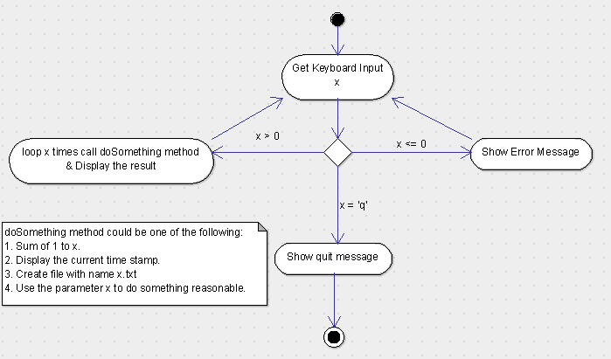

//////////////Main.java

//scanner import

import java.util.*;

public class Main

{

public static void main(String[] args) {

//Setup scanner and variables

Scanner scan = new Scanner(System.in);

int x = 0;

String input = "";

//read input and validate

while (!input.equals("q") )

{

//prompt and read input

System.out.println("Enter X > 0 or q.");

input = scan.next();

//validate input

try{

if (input.equals("q"))

break;

x = Integer.parseInt(input);

//if valid execute doSomething

if (x >0 )

System.out.println(doSomething(x));

}catch(Exception e)

{

System.out.println("Error try again.");

}

}

System.out.println("Program Exit");

}

//sleeps for x amount of seconds. Doesn’t take negatives

public static String doSomething(int x)

{

try{

//sleep x seconds

Thread.sleep(x*1000);

return "Sleep successful : " +x +" seconds";

}catch(Exception e){

System.out.println("error");

return "Error";

}

}

}

1. Write a program to merge two array of int.

/******************************************************************************

Online Java Compiler.

Code, Compile, Run and Debug java program online.

Write your code in this editor and press "Run" button to execute it.

*******************************************************************************/

public class Main

{

public static void main(String[] args) {

//arrays

int [] a = {1,5,4,32,2};

int [] b = {7,6,5,4,1,2,3};

int [] merge ;

//print arrays

printArray(a);

printArray(b);

//merge

merge = mergeArrays(a,b);

printArray(merge);

}

public static int[] mergeArrays(int[] a, int []b)

{

/*

** None sorted merge of 2 arrays into one array.

** takes 2 int arrays and returns 1 int array

*/

//make new array merge

int [] merge = new int[a.length + b.length];

//add array a to merge

for (int i= 0 ; i < a.length; ++i){

merge[i] = a[i];

}

//add array b to merbe

for (int i= 0 ; i < b.length; ++i){

merge[i + a.length] = b[i];

}

return merge;

}

public static void printArray(int [] a){

/*

** function for printing int array

*/

for (int i = 0; i < a.length; ++i)

{

System.out.print(a[i]+" ");

}

System.out.println("");

}

}

1. Write a program to find the second largest number inside an array of int.

/******************************************************************************

Online Java Compiler.

Code, Compile, Run and Debug java program online.

Write your code in this editor and press "Run" button to execute it.

*******************************************************************************/

public class Main

{

public static void main(String[] args) {

//arrays

//{1,5,4,32,2} : 5, {1,1,1,1} : 1, {-1, 0, 1}: 0,

int [] a = {10, 5,4,3,2,1,9};

//print arrays

printArray(a);

System.out.println("Second Highest : "+ findSecondHighest(a));

//merge

}

public static int findSecondHighest(int [] a )

{

if (a.length <2)

return 0;

int highest = a[0];

int secondHighest = a[1];

for (int i = 0; i < a.length; ++i){

//if new highest found then second highest can be updated

if (highest < a[i])

{

secondHighest= highest;

highest = a[i];

}

//if second highest found then update it

if (secondHighest < a[i] && a[i] < highest)

secondHighest = a[i];

}

return secondHighest;

}

public static void printArray(int [] a){

/*

** function for printing int array

*/

for (int i = 0; i < a.length; ++i)

{

System.out.print(a[i]+" ");

}

System.out.println("");

}

}